Mutiplication sums :
I. Find the product ( 3 digit by 1 digit)
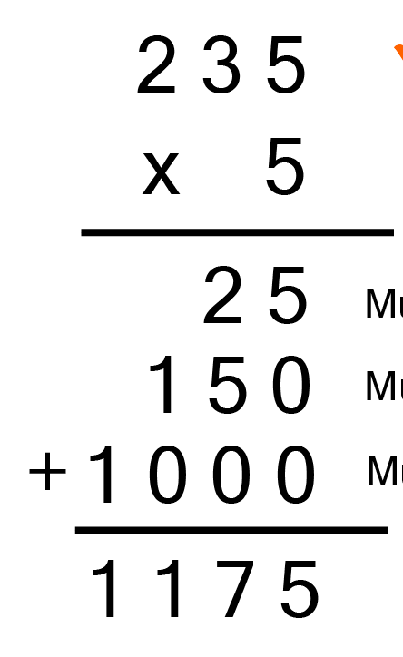
II. Find the product (3 digit by 2 digit)
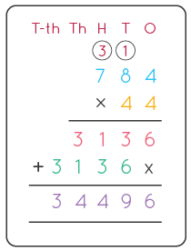

II. Find the product (3 digit by 3 digit)

